MACHINE LEARNING
1. Introduction to Machine Learning
Introduction to Machine Learning, Issues in Machine Learning, Application of Machine Learning, Steps of developing a Machine Learning Application.
Supervised and Unsupervised Learning: Concepts of Classification, Clustering and prediction, Training, Testing and validation dataset, cross validation, overfitting and underfitting of model.
Performance Measures: Measuring Quality of model- Confusion Matrix, Accuracy, Recall, Precision, Specificity, F1 Score, RMSE
PAST QUESTIONS:
- What is Machine Learning? What are the steps in developing a machine learning application? (M23, D24)
- Differentiate between supervised and unsupervised learning. (M23, D23, D24)
- Explain the overfitting and underfitting with example. (M23)
- Write short note on overfitting and underfitting of model. (D23)
- Discuss various steps of developing a Machine Learning Application. (D23)
- How to calculate Performance Measures by Measuring Quality of mode. (D23)
- Differentiate different Machine Learning approaches. What is Cross Validation? Discuss bias variance trade-off with suitable diagram. (M24)
- In the classification model, the values for the observations are as follows. True Negatives (TN) =300, True Positive (TP)=500, False Positive (FP) = 50, False Negatives (FN)=150. Evaluate the performance of the model by finding values of Accuracy, Precision, Recall and F1-Score. (M24)
- List various applications of machine learning. And describe the SPAM/Non-SPAM email filtering application in detail. (D24)

NOTES:

*Machine Learning :-
Machine learning (ML) is a branch of artificial intelligence (AI) focused on enabling computers and machines to imitate the way that humans learn, to perform tasks autonomously, and to improve their performance and accuracy through experience and exposure to more data.
Machine Learning is defined as “the field of study that gives computers the ability to learn without being explicitly programmed”.

*Steps in ML development :-
1. Define Problem: Clearly state the problem you want to solve.
2. Data Collection: Gather relevant data for the problem domain.
3. Data Preprocessing: Clean and prepare the data for analysis.
4. Data Splitting: Divide data into training, validation, and test sets.
5. Feature Engineering: Extract informative features from the data.
6. Model Selection: Choose the appropriate machine learning algorithm.
7. Model Training: Train the model using the training data.
8. Hyperparameter Tuning: Fine-tune model parameters for optimal performance.
9. Model Evaluation: Assess the model's performance using validation data.
10. Model Deployment: Integrate the model into production for real-time predictions.
11. Monitoring and Maintenance: Continuously monitor and update the model as
needed.

*Supervised vs Unsupervised :-
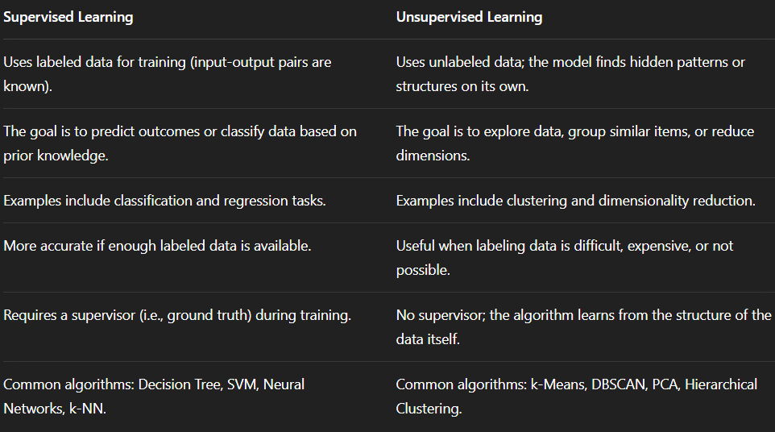
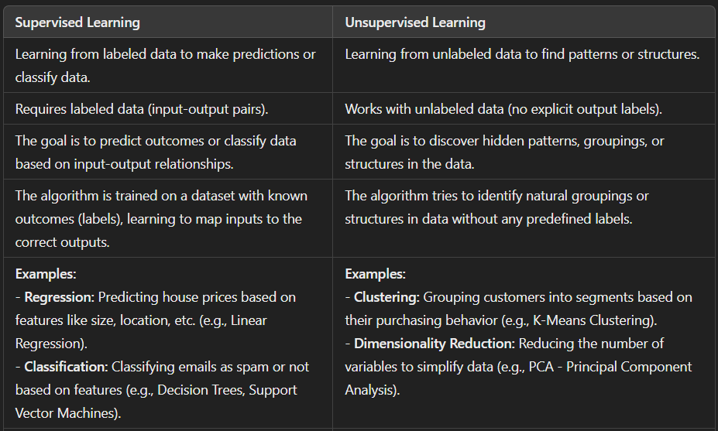

*Cross Validation :-
Cross validation is a technique used in machine learning to evaluate the performance of a model on unseen data. It involves dividing the available data into multiple folds or subsets, using one of these folds as a validation set, and training the model on the remaining folds. This process is repeated multiple times, each time using a different fold as the validation set. Finally, the results from each validation step are averaged to produce a more robust estimate of the model’s performance. Cross validation is an important step in the machine learning process and helps to ensure that the model selected for deployment is robust and generalizes well to new data.

*Applications of ML :-
1. Email Spam and Malware Filtering –
Whenever we receive a new email, it is filtered automatically as important, normal, and spam. The technology behind this is Machine learning. Below are some spam filters used by Gmail:
Content Filter, Header filter, General blacklists filter, Rules-based filters, Permission filters.
Some machine learning algorithms such as Multi-Layer Perceptron, Decision tree, and Naïve Bayes classifier are used for email spam filtering and malware detection.
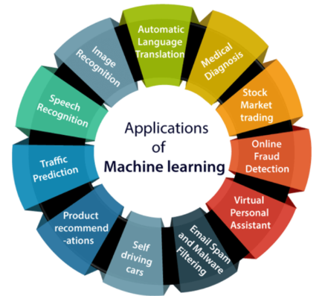

*Overfitting & Underfitting :-
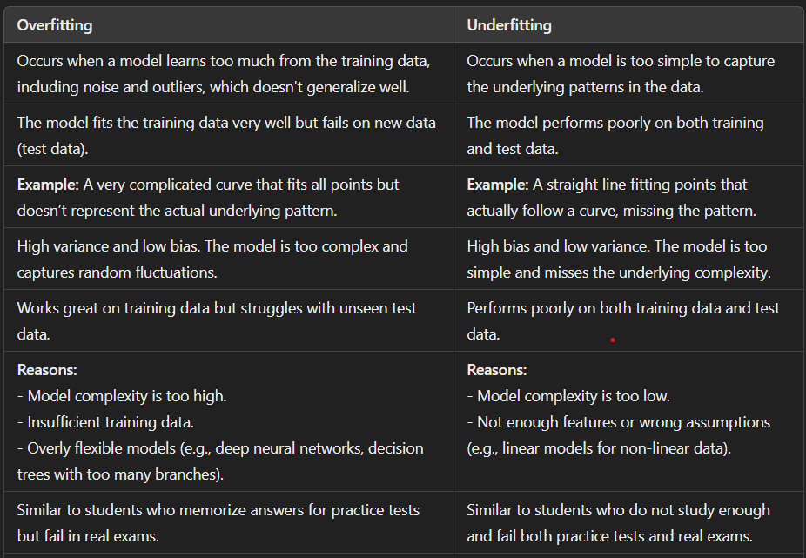
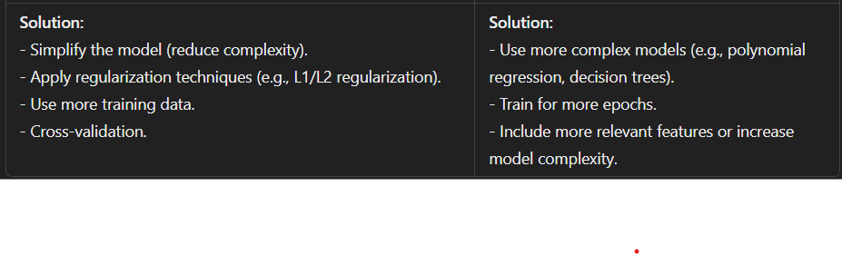

Overfitting e.g.:
1. Stock Price Prediction: A complex neural network might learn random fluctuations in historical stock prices, achieving high training accuracy but failing to predict future prices.
2. Image Recognition: A model trained on a dataset with only a few image variations (e.g., cats with one background) might learn those specific details, performing well on the training set but failing to recognize cats with different backgrounds.

Underfitting e.g.:
1. Customer Segmentation: A simple model might fail to identify distinct customer groups based on limited data, resulting in a poor segmentation.
2. Sales Forecasting: A linear regression model might fail to capture the complex seasonality of sales data, leading to inaccurate forecasts.

*Trade-off :-
Bias: The error due to overly simplistic assumptions in the model, leading to underfitting. Assumptions made by a model to make a function easier to learn. It is actually the error rate of the training data. When the error rate has a high value, we call it High Bias and when the error rate has a low value, we call it low Bias.
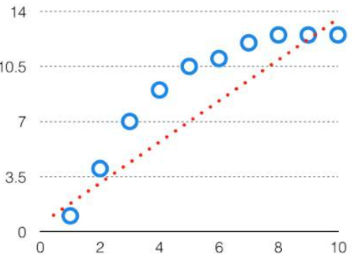
Variance: The error due to the model's sensitivity to small fluctuations in the training data, leading to overfitting.
The difference between the error rate of training data and testing data is called variance. If the difference is high then it’s called high variance and when the difference of errors is low then it’s called low variance. Usually, we want to make a low variance for generalized our model.
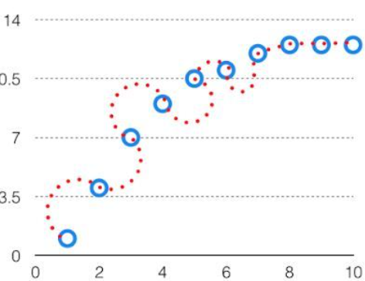
Bias-Variance trade-off: If an algorithm is too simple (e.g., linear model), it may suffer from high bias and low variance, leading to underfitting. Conversely, a highly complex model (e.g., high-degree polynomial) may have low bias but high variance, causing overfitting.
The bias-variance trade-off is the balance between these two extremes. A model must be complex enough to learn the patterns but not so complex that it memorizes the noise. The ideal trade-off minimizes total error by balancing bias and variance effectively.
For the graph, the perfect trade-off will be like this.
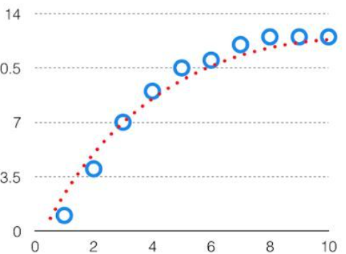

*Performance Measures :-
Confusion matrix - It is a matrix of size 2×2 for binary classification with actual values on one axis and predicted on another.
E.g.;
A machine learning model is trained to predict tumor in patients. The test dataset consists of 100 people.
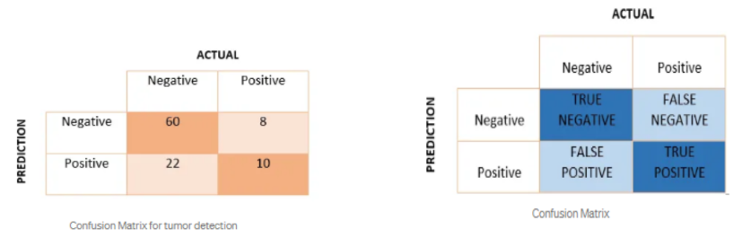
Precision - Out of all the positive predicted, what percentage is truly positive. The precision value lies between 0 and 1.
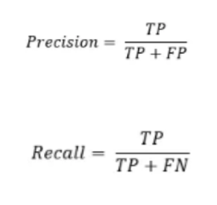
Recall - Out of the total positive, what percentage are predicted positive. It is the same as TPR (true positive rate).

RMSE - RMSE (Root Mean Squared Error) is a metric used to measure the difference between predicted and actual values in regression models. It calculates the square root of the average squared differences between predicted and true values, providing a single value that represents the model's accuracy.
Specificity - Specificity measures how well the model identifies the negative class correctly.
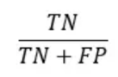
Accuracy - Accuracy measures the overall correctness of the model — how many predictions it got right out of all predictions.
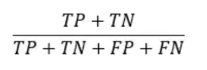
F1 score - The F1 Score is a performance metric used to evaluate the accuracy of a classification model, especially when the classes are imbalanced.
It is the harmonic mean of Precision and Recall, balancing the two:
